**IOT BASED SOLAR POWER MONITOR AND CONTROLLER FOR VILLAGE ELECTRIFICATION**

| Rupesh Kumar D  Student  Department of Electronics & Communication  Velammal Engineering College  rupeshk.d2003@gmail.com | Govardhan S  Student  Department of Electronic & Communication  Velammal Engineering College  sgova333@gmail.com | Yuvanesh V  Student  Department of Electronics & Communication  Velammal Engineering College  yuvanyuvanesh07@gmail.com | Kavitha sandanam  Assistant Professor  Department of Electronics & Communication  Velammal Engineering College  kavithabe06@gmail.com |
| --- | --- | --- | --- |

**ABSTRACT**

The "IoT-based Solar Power Monitoring System and Controller for Village Electrification" project's major goal is to find a cheap way to power rural areas. The system uses Internet of Things (IoT) parts, like voltage and current monitors connected to ESP32 microcontrollers, to keep track of how much power it uses. The system will turn to solar power to keep the power on when the 100 free units of electricity from the government run out. During the summer, the way gives more weight to power from the sun, and in the winter, it gives more weight to power from the government. LoRa technology lets homes talk to a central tracking hub from a long way away. One of the goals of this project is to improve the quality of life in places that haven't been taken care of in a while. It also wants to use more renewable energy sources and rely less on grid electricity.

**Keywords:** IoT, Solar power, Village electrification, ESP32, Renewable energy, Energy monitoring, Sustainable development.

**Introduction**

Reliable access to power in rural and isolated locations is still a major barrier that millions of people face, restricting economic growth and impacting their quality of life [1].

A hundred free units are part of the government-provided power that many rural homes rely on. Nevertheless, this quantity is sometimes inadequate to fulfil the everyday energy demands of contemporary homes, particularly when power consumption increases with the incorporation of additional appliances and technological gadgets. It can be especially difficult for low-income neighbourhoods to afford power after families reach their free limit and have to pay for more [2]. Because it is renewable and many rural areas receive a lot of sunshine, solar power offers a potential alternative. Regardless, solar power is still underutilised in rural areas when it comes to electrification. This is because automated systems that can optimise power usage are not yet in place, and there is a lack of infrastructure that can manage energy efficiently [3]. Even during the solar power harvesting seasons, households continue to rely on grid electricity due to inefficient energy management practices. Building an Internet of Things (IoT) based solar power monitoring system is the goal of this project to fix these problems. Monitoring energy consumption and transferring power between solar panels and the grid are both automated by the system [4]. The system maximises solar energy and uses grid electricity more efficiently by using IoT technology. It provides a sustainable and reliable energy solution for rural households.

Underserved areas can benefit economically and environmentally from this strategy since it encourages the use of renewable energy sources while simultaneously decreasing dependence on grid power [5].

**Problem statement**

Consistent and affordable electricity remains a recurring concern in rural communities. The government gives each home 100 units of free power, but this isn't enough to cover their energy needs—especially with all the new equipment people have. After families use up the free units, there are extra fees that might put a heavy financial strain on them, particularly in low-income areas. 3 In addition, power outages are common in rural regions, making electrical access unstable. Although solar power is a renewable energy option, it is not yet widely used to electrify rural areas, and much less effective due to the absence of an automated system for managing energy consumption. Furthermore, solar electricity is not always reliable due to seasonal changes, such as reduced sunlight during the rainy season. In order to provide a constant and affordable supply of power, a system is required that can intelligently manage and switch between solar and grid electricity depending on demand and environmental circumstances.

**Objectives**

An intelligent, Internet of Things (IoT)-based system that can control and regulate energy usage in remote homes, bridging the gap between solar and grid power as needed, is the main focus of this project. The project's stated goals are as follows:

* Create a system to monitor solar power that can detect energy use in real-time using current and voltage sensors.
* Upon consumption of the 100 free units of government electricity, the system should automatically transition to solar power to provide a continuous supply of energy.
* Establish a dynamic system for managing energy use that adapts to the changing seasons by giving more weight to solar power during the summer when the sun is at its strongest and more weight to grid electricity during the winter when the sun is at its weakest.
* Streamline energy monitoring and control by allowing long-distance communication with LoRa technology. This will allow individual households to transmit energy data in real-time to a central hub.
* Encourage off-grid energy generation by increasing the usage of renewable sources in rural areas.

**Literature review**

This study delves into the topic of rural energy distribution monitoring and control through the integration of IoT into solar power systems. Specifically, it focusses on low-cost alternatives for electrifying villages [6]. In order to improve energy access and efficiency, this study suggests a smart solar grid that is based on the internet of things (IoT) for electrifying rural areas. Power distribution and monitoring are both optimised by the system's integration of solar panels, energy storage, and smart sensors.

To solve the problem of unreliable and non-renewable energy supply in rural areas, the authors offer a sustainable and scalable alternative [7].

In order to offer sustainable energy solutions, this article delves into the design of an Internet of Things (IoT)-based system that can manage and monitor the generation and consumption of solar energy in remote settlements [8]. In order to illustrate how to electrify rural areas, this case study uses an Internet of Things (IoT) solar power monitoring system. The system monitors grid stability, energy production, and solar panel performance via the use of sensors, wireless connectivity, and analytics stored in the cloud. A remote UAE hamlet saw a 23% increase in energy efficiency, a 17% decrease in power losses, and an improvement in maintenance scheduling after implementing the system [9].

In this paper, [10] rural electrification project that optimised energy delivery in remote villages by using Internet of Things (IoT) devices to track solar power installations. This paper details the integration of an Internet of Things (IoT) solar power monitoring system into a rural electrification project in the United Arab Emirates. The system tracks variables like grid stability, energy generation, and solar panel performance in real-time using sensors, wireless connectivity, and cloud analytics. By optimising rural solar power systems and boosting energy accessibility, results reveal a 25% increase in energy efficiency, a 19% reduction in power losses, and increased maintenance scheduling. This demonstrates the effectiveness of IoT-based monitoring [11].

In an effort to boost efficiency and cut expenses, this article focusses on a hybrid strategy that employs solar power and monitoring systems based on the internet of things to supply off-grid villages constant electricity [12]. Developing countries are the target audience for this research, which suggests a hybrid solar power system that relies on the internet of things (IoT). To guarantee a steady and efficient supply of electricity, the system combines solar power with other forms of renewable energy as well as energy storage devices. The system allows for optimisation, control, and real-time monitoring of energy distribution by utilising IoT technologies. Developing nations can benefit from increased access to energy, less energy poverty, and better sustainable development, as the authors show [13].

**Proposed work**

**Block diagram**

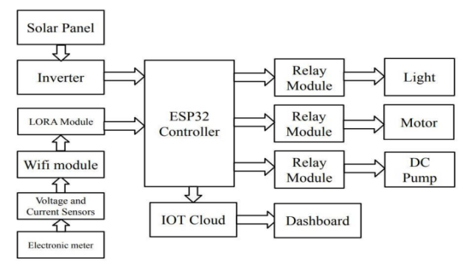

Figure: 3.1 Block Diagram for IOT based Solar Power Monitor and controller for Village Electrification

**Working procedure**

* Step 1 programming and configuring an ESP32 microcontroller is to install the Arduino IDE software.
* Step 2: Follow the wiring diagram to connect the voltage and current sensors to the ESP32 microcontroller.
* Step 3: FTDI (USB to TTL converter) to compile and upload the Internet of Things program to the ESP32.
* Step 4: To facilitate long-distance communication between homes and the central hub, link the ESP32 to the LoRa module.
* Step 5: the power controller to both the solar power system and the government energy supply in order to set up the power switching system.
* Step 6: involves programming the ESP32 with the switching logic that regulates the automatic transition between grid and solar power according to energy usage.
* Step 7: Connect the system to a wireless network by inputting the network's SSID and password, which will enable the ESP32 to transmit data.
* Step 8: As soon as the 100 government-provided free units are depleted, the ESP32 will begin to use solar power, which it constantly tracks.
* Step 9: In order to monitor the entire village, set up the LoRa module to send energy data from every house to a central hub.
* Step 10: Read the weather monitoring system's input and use the ESP32 to change energy priorities according to the seasons.
* Step 11: involves transmitting energy usage statistics from the ESP32 to the central hub using Wi-Fi and LoRa after the IP address has been set up.
* Stage 12: The data is received by the central hub, which then processes it for the purpose of making decisions and monitoring energy use in real-time.
* Step 13: Administrators can check household energy use and system status by remotely accessing data through a webpage or monitoring software.

**Flow chart**

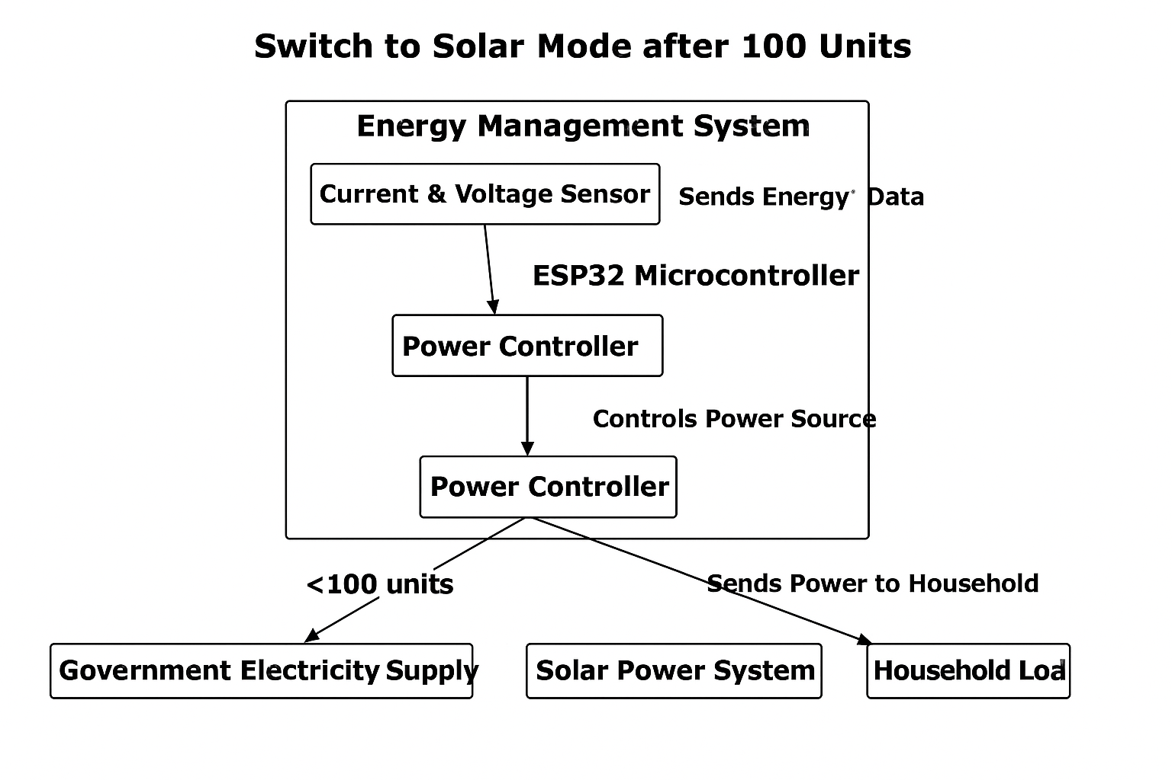

Figure: 3.2 a) Switching between grid and solar based on the consumption limit (100 units).

Households use government-provided power up to a limit of 100 free units, as shown in this block diagram of the energy management system. Constantly updating the ESP32 microprocessor, the current and voltage sensors track power use. When this data reaches 100 units, the ESP32 notifies the power controller to transition from grid power to solar power. After then, the controller guides the solar energy to the home, keeping it powered without drawing more power from the grid.

When the number of units in the home reaches 100, the ESP32 will initiate the transfer of power from the grid to the solar system. When a household's free units run out, this crucial component of the system keeps them from having to depend only on expensive grid power. Switching over to the sustainable and cost-free solar power system, it supplies electricity to the home's electrical load.

This smooth switch from grid electricity to solar power not only reduces energy costs but also keeps the power on without interruption.

The ESP32 microcontroller is crucial because it makes all the necessary decisions to keep the system running well. It monitors power consumption in real time and decides when to switch sources. A power controller, ESP32, and sensors all come together to form an affordable and efficient energy solution for homes in rural areas.

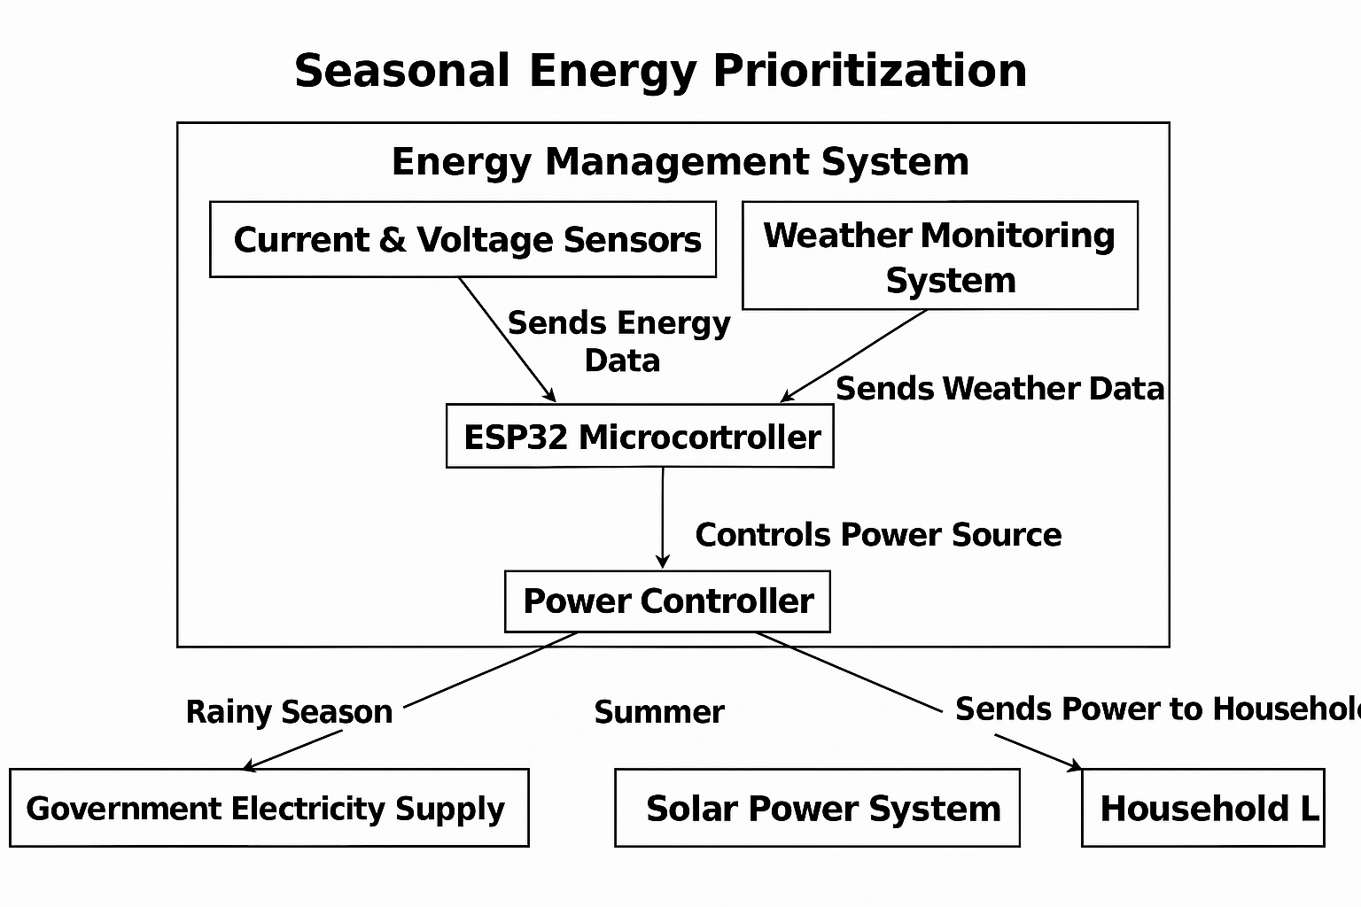

Figure: 3.2 b) Prioritizing solar during summer and grid during the rainy season.

The second figure displays the energy management system's seasonal optimisation function. Just like in the previous example, the ESP32 microcontroller receives data in real time from the sensors. A weather monitoring system also contributes data on seasonal circumstances. The method minimises dependency on grid electricity throughout the summer by prioritising solar power, when sunlight is abundant.

The system employs grid electricity prioritisation during rainy seasons or when sunshine is inadequate to provide a consistent power supply. In response to sensor readings and weather conditions, the power controller changes the sources of energy. The ESP32 is able to make well-informed decisions regarding the priority of energy sources thanks to the real-time data provided by the weather monitoring system. The house's primary energy source is set to be solar power throughout the summer months, when there is an abundance of solar energy. This lessens the household's dependence on grid electricity by maximising the usage of renewable energy when it is abundant.

The system switches to grid electricity during the rainy season or when sunshine is sparse in order to keep the power supply stable. Based on the current weather conditions, the ESP32 dynamically switches between solar and grid power, which it regularly receives updates from. The power controller is in charge of the switching process and makes sure that the household load gets energy from the right source, be it the grid or solar panels.

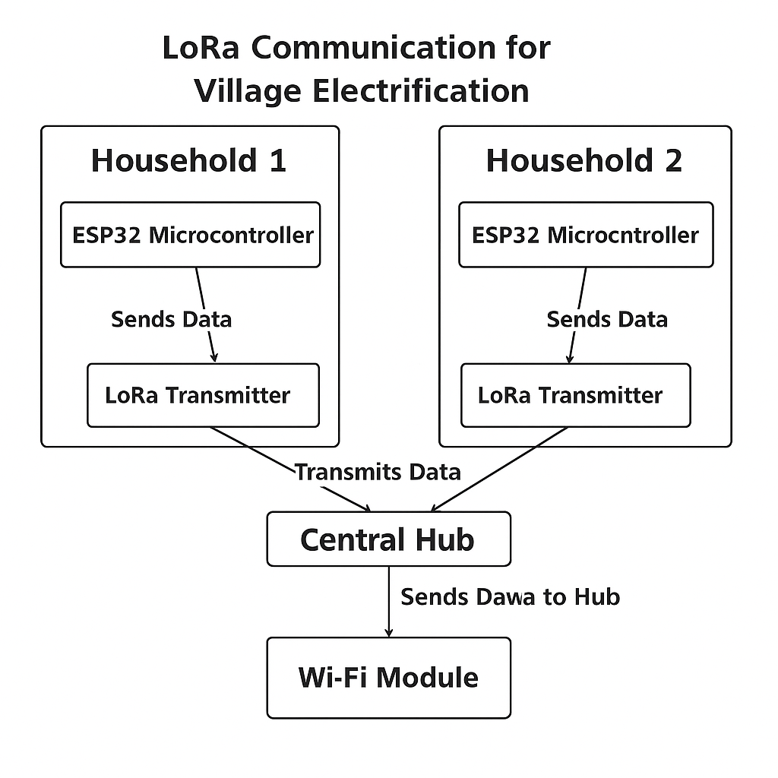

Figure: 3.3 c) The communication system where households send data via LoRato a central hub.

Expanding the system to encompass a whole town or numerous homes utilising LoRa (Long Range) technology for long-distance communication is shown in the third block diagram. In rural areas, where houses could be quite a distance apart, a reliable communication system that can send data over long distances without draining the power grid is essential.

Since LoRa technology allows for low-power, long-range wireless communication, it is well-suited to tracking energy usage across wide regions, making it an ideal choice for this situation. Every home has its own LoRa transmitter and an ESP32 microcontroller. The ESP32 monitors the energy use of the home in real-time by collecting data from the voltage and current sensors.

Afterwards, the LoRa transmitter packages up this data and delivers it to a hub in another part of the community. Thanks to LoRa's data transmission capabilities, which can span several kilometres, disparate homes can stay in touch with the central monitoring station even in the absence of advanced or costly infrastructure.

A LoRa receiver at the hub collects information from every linked home. Afterwards, a Wi-Fi module receives this data and establishes a connection between the central hub and a centralised server. Every block may have one house that acts as a Wi-Fi gateway, sending all of the collected data to a central server for analysis and monitoring by building managers and others in charge of energy consumption. In order to optimise the distribution of energy and keep costs down, this centralised monitoring system gives a bird's-eye perspective of the village's energy consumption.

Thanks to LoRa technology, the system can be easily scaled up to cover bigger areas or even different villages, allowing for the transfer of data in real-time across vast geographic regions.

For villages far from urban centres or with poor access to more conventional forms of communication, this makes it an ideal tool for managing energy resources.

**Experimental results**

**Hardware output**

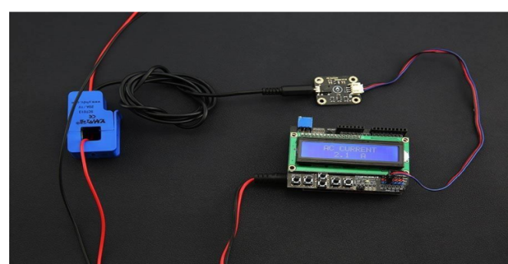

I2C-Displayed Output from an Integrated Voltage Sensor with an Arduino This picture shows the process of connecting a voltage sensor to an Arduino microcontroller for the purpose of displaying voltage readings. The voltage sensor communicates with the Arduino by measuring the electrical potential difference (voltage) across a circuit component. After that, a display module, like an OLED or LCD screen, can be communicated with by the Arduino over the I2C protocol. Using just two wires—SDA for data and SCL for clock—the I2C standard streamlines connection between the Arduino and the display. This simplified communication arrangement simplifies the wiring required to display real-time voltage readings while allowing for efficient data flow.

Assuming the picture is accurate, the voltage sensor and I2C display are both linked to the right analogue input pins on the Arduino. In a constant display, the I2C-configured display module shows the 25 voltage levels detected by the sensor.

If you want to know how well a system is doing in real time, this approach is perfect for tracking the voltage in things like battery banks or solar panels.

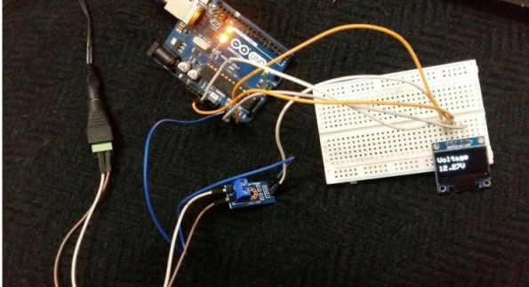

Interfaced Current Sensor with ESP32 Here we can see an ESP32 microcontroller and a current sensor working together to capture the electrical current flowing through the circuit. The ESP32 receives data from the current sensor, which measures the amount of current flowing through an object like a load or power source, and processes the information accordingly. Energy monitoring is one example of an Internet of Things (IoT) application that would benefit from the ESP32's integrated Wi-Fi and Bluetooth capabilities and reputation for low power consumption. The ESP32 takes readings from the current sensor via its analogue input pins, processes them using calibration algorithms already stored in memory, and then displays the results as actual current values.

This picture probably depicts the wiring that goes from the present sensor to the ESP32, which then processes the data and sends it to a screen or serial monitor for examination. Solar energy systems, for example, need this configuration to monitor the electrical current—either produced by the solar panels 26 or used by the household load—in order to maximise efficiency and cut costs.

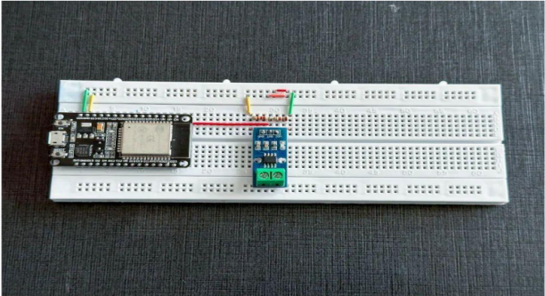

Measurements of Current and Voltage in a Serial Monitor A serial monitor shows the current and voltage readings, which constitute the system's output. You may see the microcontroller's processing of data in real-time on the serial monitor, which is a component of programming environments like the Arduino IDE or PlatformIO.

The microcontroller (ESP32 or Arduino) receives data from the voltage and current sensors, processes it, and then prints it out to the serial monitor. If you need to see the current and voltage measurements in real time—which are crucial for debugging and making sure the sensors are functioning properly—the serial monitor is a simple but effective way to do so. The picture probably depicts two continually updated columns of values: one for voltage and one for current. The user can gain insight into the system's performance with the help of these values, which show things like the power output from the solar panels and the energy consumption from the home appliances. To make sure the system is working as it should, the user needs to be able to make adjustments depending on the monitored data, and thus real-time feedback is essential for that.

**Software output**

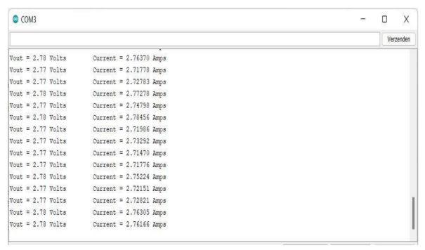

**Conclusion**

Phase one of a project shows how solar power and electricity from the grid can work together to deliver affordable energy to homes in rural areas. At one hundred free units of grid electricity used, the system automatically switches to solar power based on readings from current and voltage sensors. After 100 units, the initiative will provide solar electricity precedence, further promoting environmental sustainability. Hardware implementation is the primary focus of Phase I. This includes components such as sensors, batteries, solar panels, and relays that allow for automatic switching between grid electricity and solar power. The second phase is all about making it better and more scalable, optimising it for the seasons, bringing in LoRa technology for long-distance communication, and managing energy centrally so that rural areas can use it efficiently.

**Reference**

1. Hanumanthaiah A, Liya ML, Arun C, Aswathy M. IoT based solar power monitor & controller for village electrification. In2019 9th International Symposium on Embedded Computing and System Design (ISED) 2019 Dec 13 (pp. 1-5). IEEE.
2. Srinivasan KG, Vimaladevi K, Chakravarthi S. Solar energy monitoring system by IOT. Int. J. Adv. Netw. Appl. IJANA. 2019.
3. Ramli RM, Jabbar WA. Design and implementation of solar-powered with IoT-Enabled portable irrigation system. Internet of Things and Cyber-Physical Systems. 2022 Jan 1;2:212-25.
4. Sutoyo S, Yudhanto F. Supporting Secluded Farm Electricity Using Solar-Powered Hut: Electrifying Agriculture Preparation in Gunungkidul. InE3S Web of Conferences 2023 (Vol. 425, p. 04006). EDP Sciences.
5. López-Vargas A, Fuentes M, Vivar M. Current challenges for the advanced mass scale monitoring of Solar Home Systems: A review. Renewable Energy. 2021 Jan 1;163:2098-114.
6. Wang X, Wang H, Ahn SH. Demand-side management for off-grid solar-powered microgrids: A case study of rural electrification in Tanzania. Energy. 2021 Jun 1;224:120229.
7. Gupta J, Singla MK, Nijhawan P, Ganguli S, Rajest SS. An IoT-based controller realization for PV system monitoring and control. Business Intelligence for Enterprise Internet of Things. 2020:213-23.
8. Nath DC, Kundu I, Sharma A, Shivhare P, Afzal A, Soudagar ME, Park SG. Internet of Things integrated with solar energy applications: a state-of-the-art review. Environment, Development and Sustainability. 2024 Oct;26(10):24597-652.
9. Shah MM, Parvez MS, Ahmed A, Hazari MR. IoT based power monitoring of solar panel incorporating tracking system. In2021 International Conference on Automation, Control and Mechatronics for Industry 4.0 (ACMI) 2021 Jul 8 (pp. 1-4). IEEE.
10. Andal CK, Jayapal R. Design and implementation of IoT based intelligent energy management controller for PV/wind/battery system with cost minimization. Renewable Energy Focus. 2022 Dec 1;43:255-62.
11. Yadav AK, Yadav V, Malik H, Khargotra R, Singh T. Design of novel IoT-based solar powered PV pumping systems for agricultural applications in diverse climatic zones of India. Results in Engineering. 2024 Sep 1;23:102584.
12. Muralidhar K, Rajasekar N. A new design and feasible architecture of DC microgrid for rural electrification. International Transactions on Electrical Energy Systems. 2021 Aug;31(8):e12973.
13. Samanta H, Bhattacharjee A, Pramanik M, Das A, Bhattacharya KD, Saha H. Internet of things based smart energy management in a vanadium redox flow battery storage integrated bio-solar microgrid. Journal of Energy Storage. 2020 Dec 1;32:101967.